Connecting to TigerBridge

Trevor Holland

01/27/25

1. Connect the TigerStop Pro Controller’s ethernet port to a network source that can provide an IP address over DHCP such as a router.
2. In the controller’s settings, under “My Machine”, locate the setting for “IP Address”. A valid IP address should appear as this setting’s value; take note of this value.

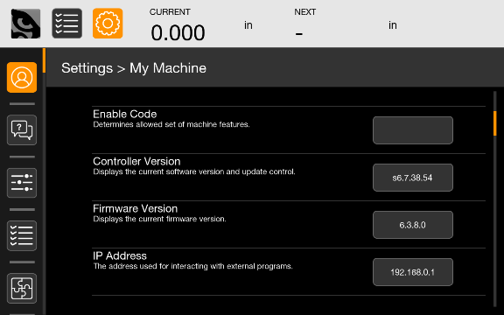

1. Also in the “My Machine” group of the controller’s settings, there is a setting called “TigerBridge”. Open this setting and press the button in the bottom right to enter TigerBridge mode. It should now be possible to connect to the TigerBridge server.

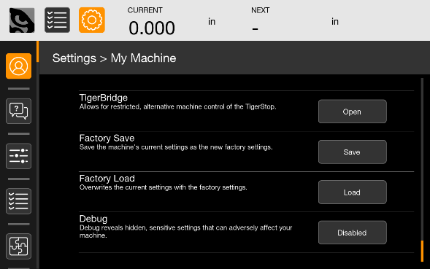

1. Connect a separate computer to the same DHCP network. Download (method TBD) the TigerBridge example python project onto this computer. Using the provided python example, import the TSPro class. The ‘connect’ method of the TSPro class can be used with the controller’s IP address to connect to it. Here’s an example of some code that would connect to a controller with the address “192.168.0.1”.

from tiger_bridge import TSPro

tsp = TSPro()

ip_address = "192.168.0.1"

result = tsp.connect(ip_address)

if not result:

print("failed to connect")

return